Uva Wellassa University of Sri Lanka Faculty of Applied Sciences  Department of Computer Science and Informatics  Undergraduate Research Project (CST/IIT)- 2024/2025 |  |  |  | 
PROGRESS REPORT Report No: |  |  |  | 05
Name of the student/s: | W.K.Gayan
Registration Number/s: | UWU/IIT/21/062
Degree Programme/s: | Industrial Information Technology
Title of the Study: | AI-Based Tomato Ripening Stage Detection and Sorting System with Shelf-Life Estimation for the Commonly Consumed Padma Variety in Sri Lanka Using Computer Vision and Conveyor Automation
Institute/s where studies  are affiliated with: | Uva Wellassa University of Sri Lanka
Name of the Supervisor/s: | Ms. D.P. Jayathunga(Principle supervisor)  Dr. U.G.A.T. Premathilake (Co-Supervisor)  Ms. M.P.A.M. Rathnakumara (Co-Supervisor)
Period of Progress: | From:16/05/2026 |  | To:14/06/2026
Progress (A description by the student).
1) Accomplished Activities
During this reporting period, the project focused on enhancing the mechanical structure and improving the readiness of the prototype for conveyor system integration. The primary activities involved refining the external appearance of the prototype, developing an adjustable camera mounting mechanism, and fabricating essential conveyor support components.
The external frame of the prototype was painted to improve durability and provide a professional finish while protecting the metal structure from environmental effects. This step also enhanced the overall appearance of the system in preparation for future demonstrations and testing.
Additionally, an adjustable camera mounting mechanism was designed and fabricated. The mounting system allows the camera position and angle to be adjusted along a single axis, enabling flexibility in image acquisition and optimization of the camera’s field of view during tomato ripeness detection experiments.
To support the conveyor system, six custom bracket assemblies were designed and fabricated. Each bracket was integrated with bearings to ensure smooth roller movement and reduce friction during conveyor operation. These components will contribute to stable and efficient belt movement in the subsequent assembly stages.
Milestones Achieved
- Prototype Surface Finishing: Completed painting of the external prototype structure for improved durability and appearance.
- Adjustable Camera Mount Development: Designed and fabricated a movable camera mounting mechanism with position adjustment capability.
- Camera Positioning Enhancement: Improved flexibility for future image capture and calibration processes.
- Conveyor Support Component Fabrication: Manufactured six bracket assemblies for roller installation.
- Bearing Integration: Installed bearings within the brackets to ensure smooth roller rotation and conveyor belt operation.
- Mechanical Readiness Improvement: Prepared key structural components required for conveyor assembly.
Figure 1: Adjustable camera mounting mechanism installed on the prototype.
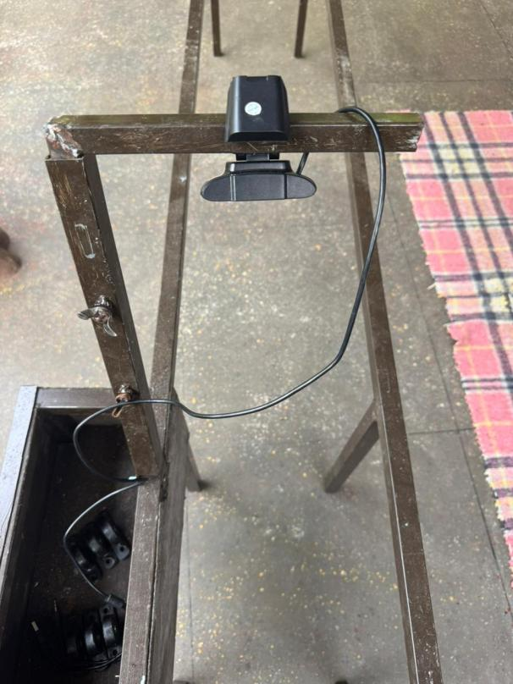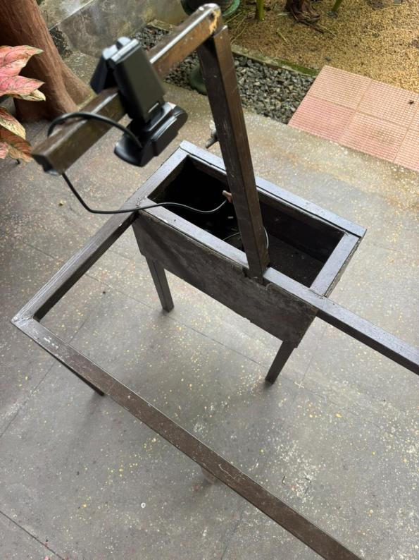

Figure 2: Fabricated bracket assembly with integrated bearing for conveyor rollers.
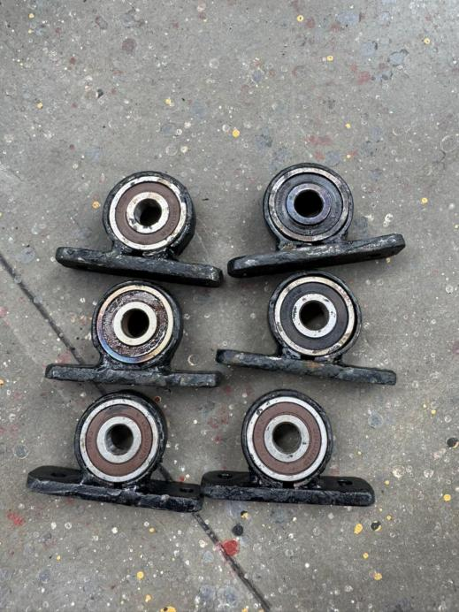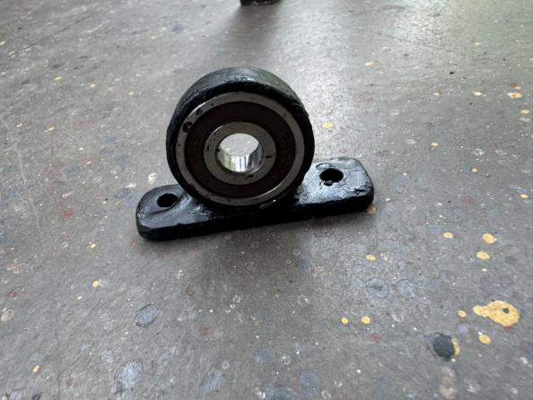
2) Activities Planned for the Next Period
The upcoming phase will focus on assembling the conveyor mechanism and integrating the fabricated components into a functional system. The goal is to establish a fully operational conveyor platform for hardware and software testing.
Planned Activities
- Install the conveyor rollers using the fabricated bracket assemblies.
- Assemble and align the conveyor belt mechanism.
- Mount and secure the camera using the adjustable camera support system.
- Begin testing conveyor movement and roller performance.
- Continue development and integration of the tomato detection system with the hardware platform.
- Perform initial calibration of the camera setup for image acquisition.
Signature of the Student: |  | 
Approval Signature of Supervisor:
Approval Signature of Co-Supervisor (If any):
Date: |  | 14/06/2026

